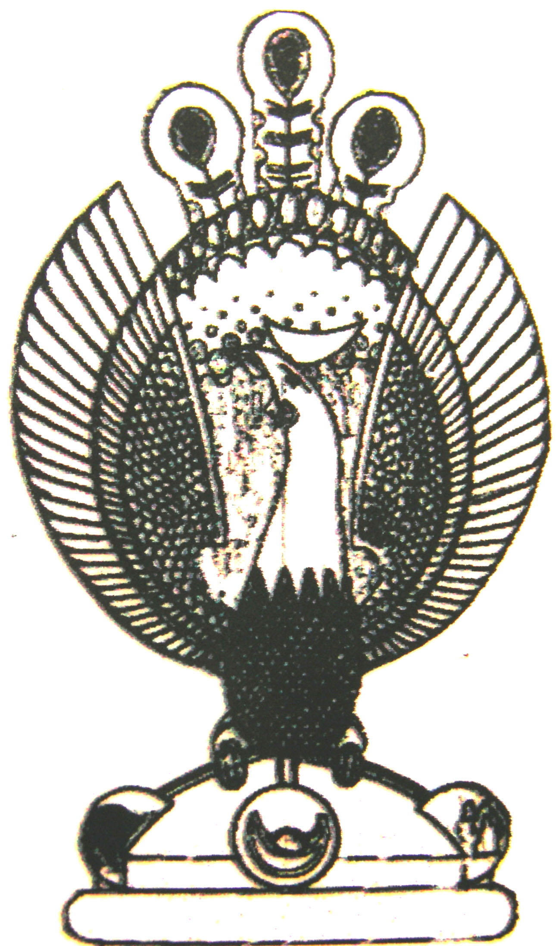

THE HERITAGE

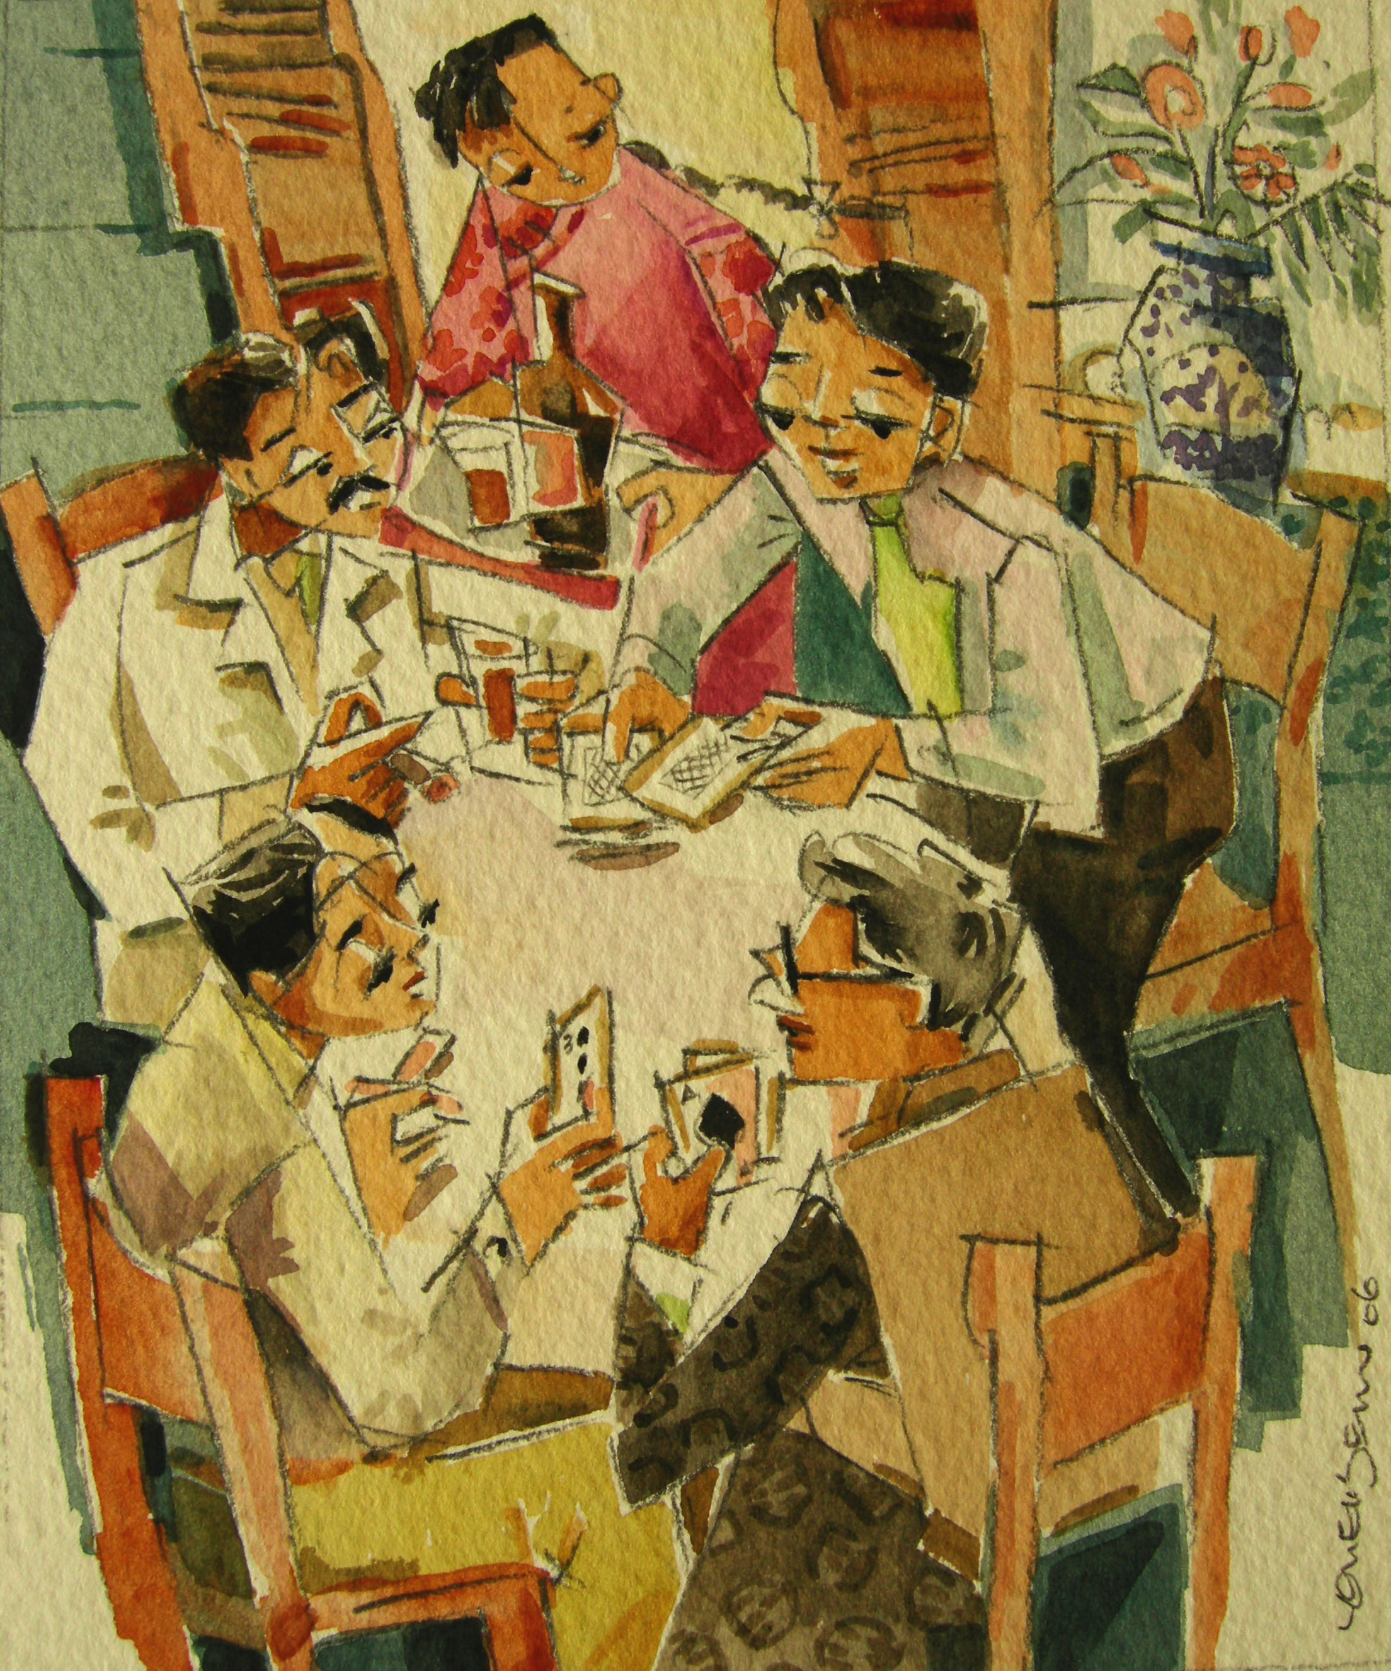
Club House
True to their nature, the peranakans loved to gamble. Those with money to spend wound often be seen at entertainment clubs, where many of its patrons included the Baba elite. Stakes were often high, sometimes going up to as much as the ownership of a house.

